Experiment  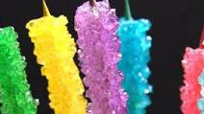  Learn about crystals:  Rock Candy Experiment | Learn  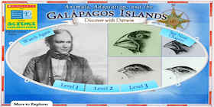  Discover with Darwin | Try  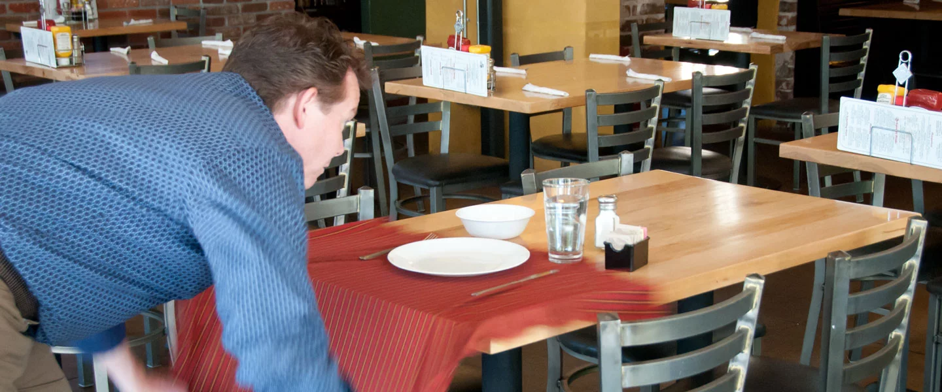  Some Physics with  Whip off the Tablecloth Trick | Experiment  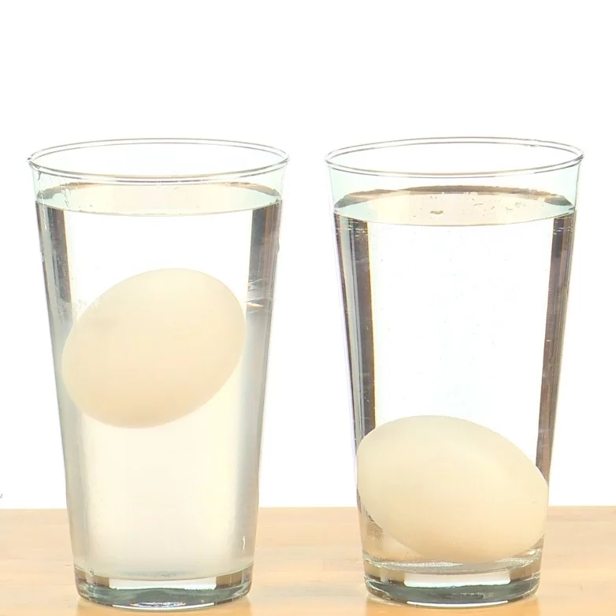  Density  Floating Egg Experiment
Make  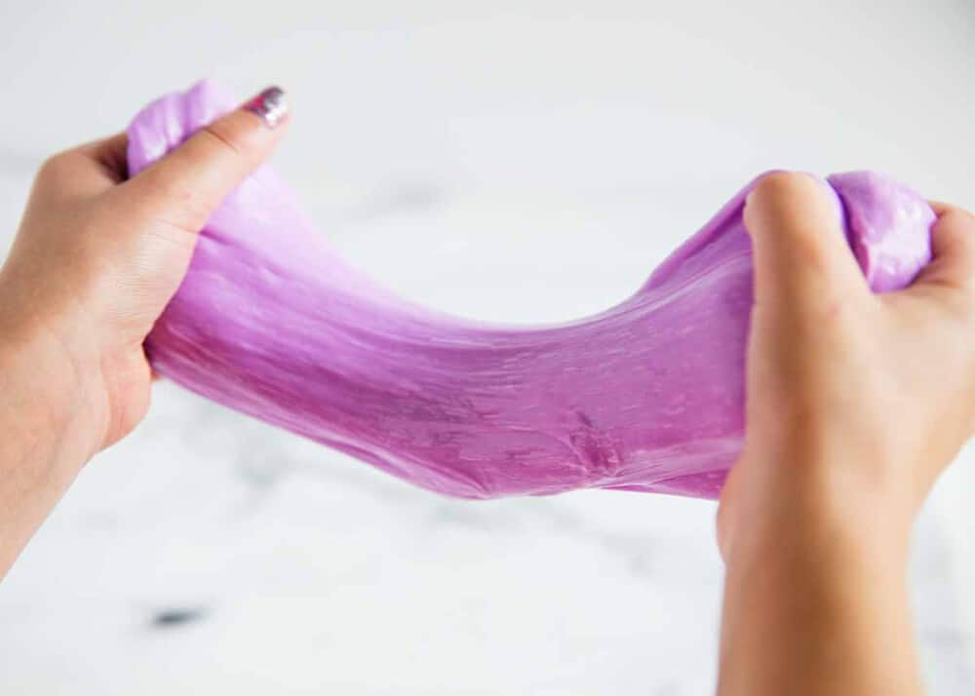  Slime Recipe 1  Slime Recipe 2  A Few More Slime Recipes | Science  &  Engineering  Choice Board |  | Make  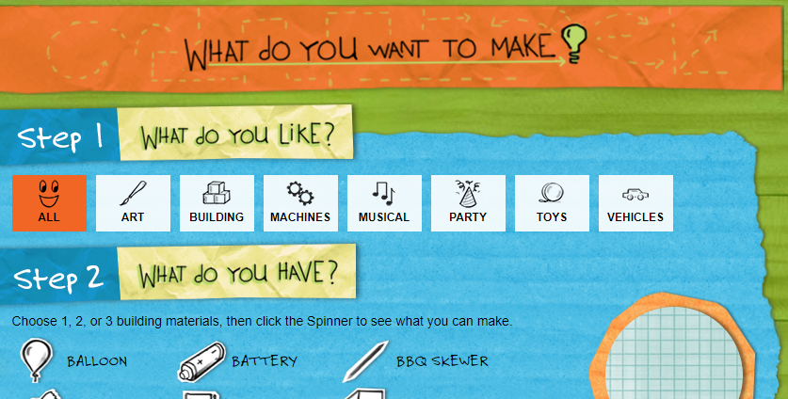  Build with materials you have on hand- choose what you want to make!  Design Spinner
Experiment  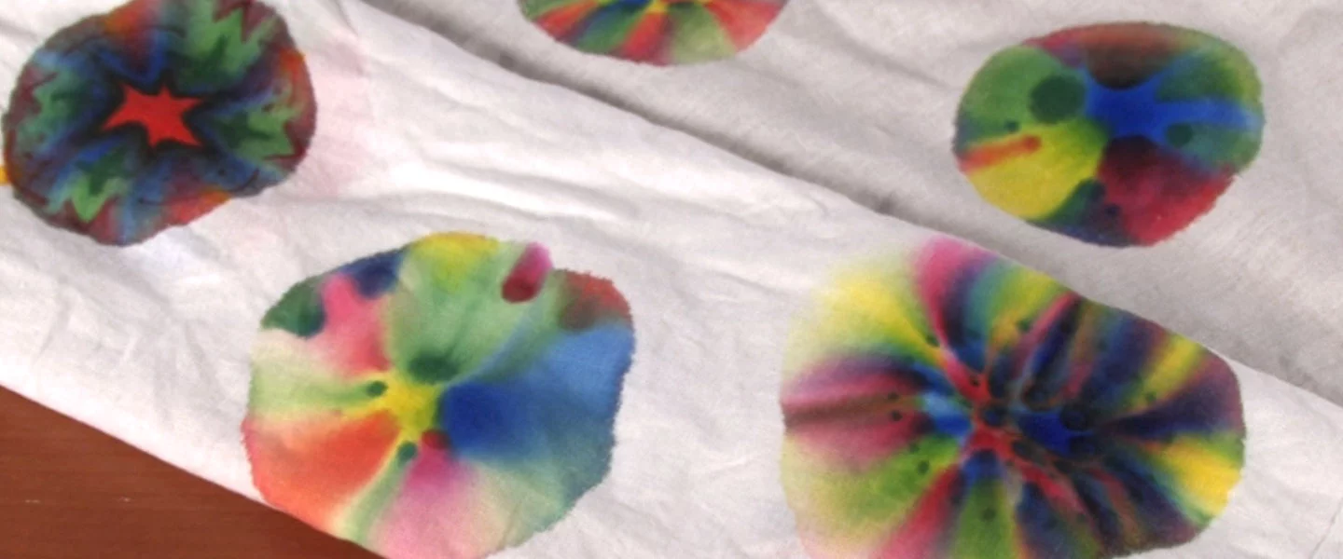  Learn about solubility:  Sharpie Science | Learn    About  Newton's Laws of Motion | Interact  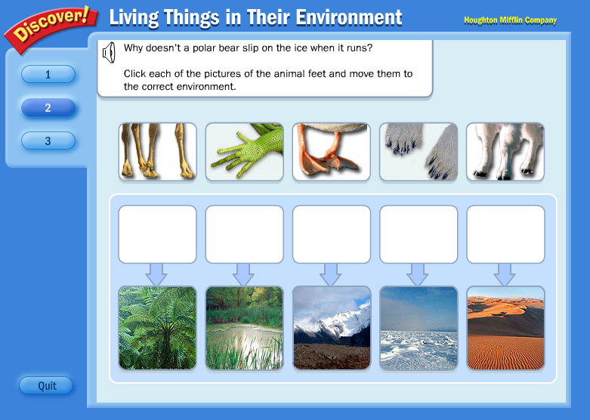  Animal Adaptations and Their Environments | Experiment    Learn about density:  Liquid Layers

